World Geothermal Congress 2023, Beijing, China, 15th – 17th September, 2023
https://www.wgc2023.com/wgc2023/en/
During the Congress a poster of GEO4CIVHIC was exposed related to a paper submitted and accepted: Bernardi A. et al.“Ground Source Heat Pump Systems Applied To Historical Buildings To Improve Their Energy Efficiency”.
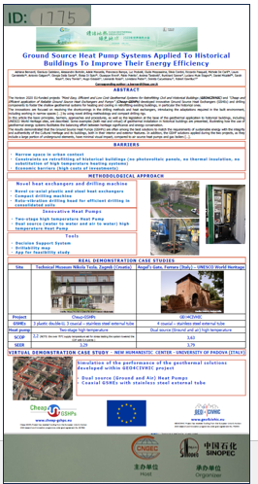
Figure : Presentation of poster at theWGC23 event

